

Capstone Project Report
Report 4 – Software Design Specification

– Hanoi, Aug 2026 –

Table of Contents
Change Log 3
I. High Level Design 4
1. Software Architecture 4
2. Package Diagram 5
3. Database Design 5
3.1 table_name1 6
3.2 users 6
3.3 table_name3 6
II. Detailed Code Design 6
1. <Feature/Function Name1> 6
1.1 Class Diagram 6
1.2 <Sequence Diagram Name1> 6
1.3 <Sequence Diagram Name2> 7
2. <Feature/Function Name2> 7
III. Design for Non-Functional Requirements 7
1. Security Design 7
1.1 Authentication Flow 7
1.2 Authorization & RBAC Implementation 8
1.3 Data Protection 8
2. Performance & Scalability Design 8
2.1 Caching Strategy 8
2.2 Database Query Optimization 8
IV. Other Design Specifications 8

Change Log
Date | A*  M, D | In charge | Change Description
*A - Added M - Modified D - Deleted

I. High Level Design

1. Software Architecture
[The content of this section includes the overall architectural diagram which includes the sub-systems and/or components, the external systems (if any), and the relationships (communication messages) among them. You need also provide the explanation for each of the diagram components (modules, sub-systems, external systems, etc.)].
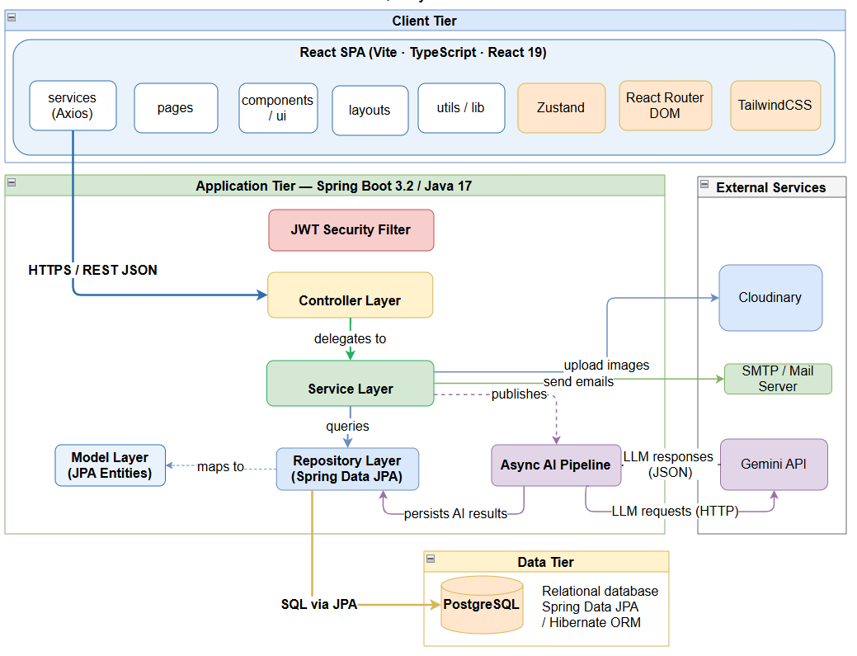
Architecture component descriptions
No | Component | Description
Client Tier
01 | pages | <Description of the component>
02 | …
Application Tier
01 | JWT Security Filter | <Description of the component>
02 | …

2. Package Diagram
[Provide the package diagram for each sub-system. The content of this section including the overall package diagram, the explanation, package and class naming conventions in each package.]
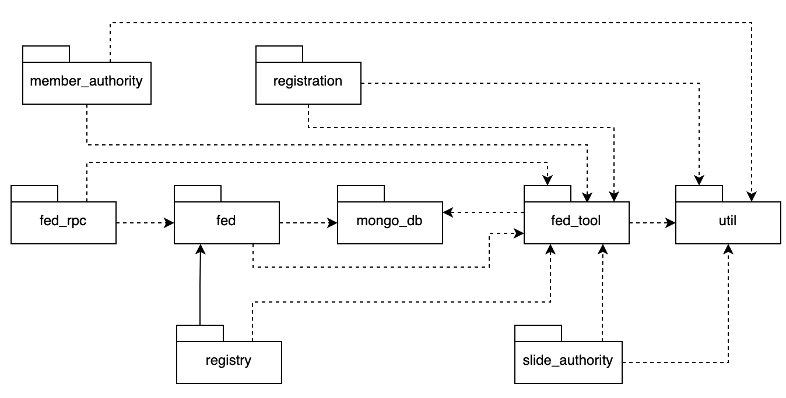
Package descriptions
No | Package | Description
01 | member_authority | <Description of the package + class naming conventions>
02 | …

3. Database Design
[Provide the files description, database table relationship & table descriptions like example below]
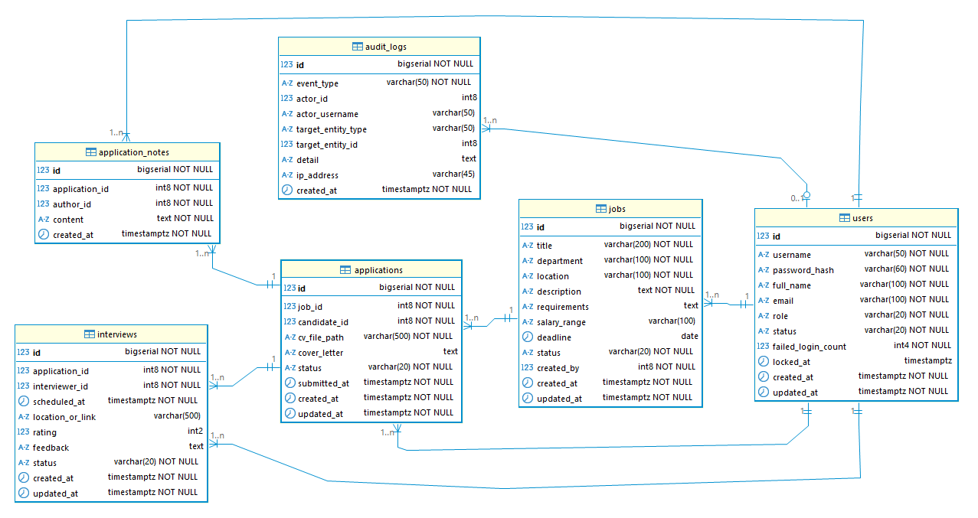

3.1 table_name1
[Add one table block per additional entity following the same structure.]
Column | Type | Constraints | Notes
{{COLUMN}} | {{TYPE}} | {{CONSTRAINTS}} | {{NOTES}}
created_at | TIMESTAMP | NOT NULL, DEFAULT NOW()
updated_at | TIMESTAMP | NOT NULL

3.2 users
Column | Type | Constraints | Notes
id | BIGSERIAL | PRIMARY KEY | Auto-increment
username | VARCHAR(50) | NOT NULL, UNIQUE | Login identifier; [a-zA-Z0-9_] only
password_hash | VARCHAR(60) | NOT NULL | BCrypt hash; never store plaintext
full_name | VARCHAR(100) | NOT NULL
email | VARCHAR(100) | NOT NULL, UNIQUE
…

3.3 table_name3
…

II. Detailed Code Design
[Provide detailed design set for features involving the most integrations with the backend and external services, limit at 2-3 design sets. Each set includes Class Diagram and Sequence Diagram(s)]

1. <Feature/Function Name1>

1.1 Class Diagram
[This part presents the class diagram for the relevant feature]
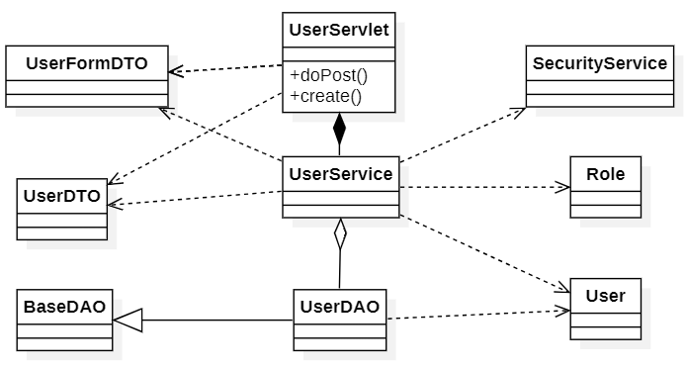

1.2 <Sequence Diagram Name1>
[Provide the sequence diagram(s) for the feature, see the sample below]
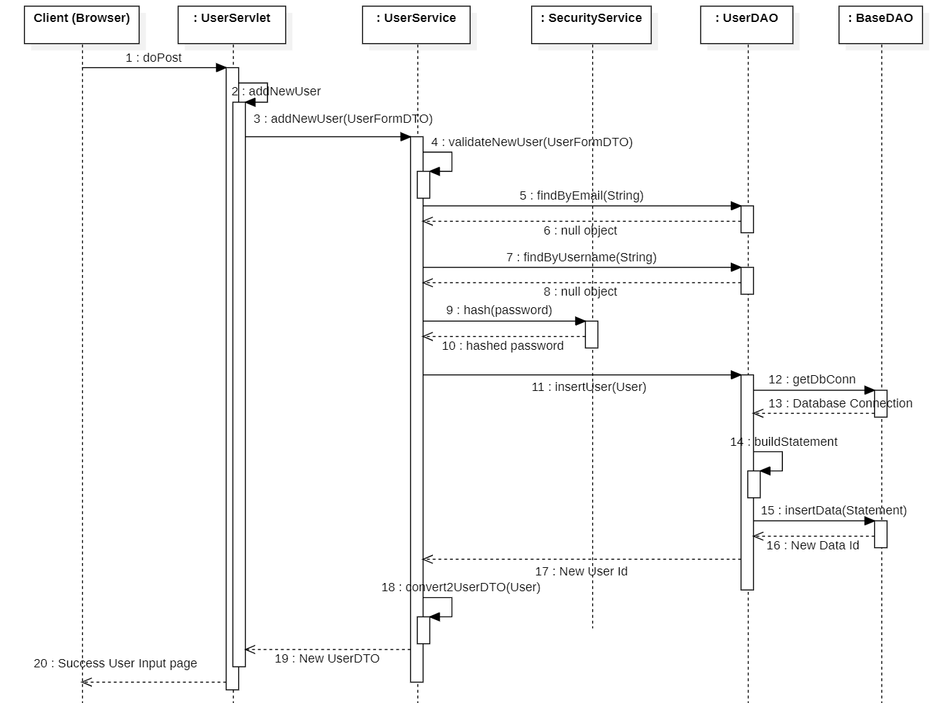

1.3 <Sequence Diagram Name2>
…

2. <Feature/Function Name2>
…

III. Design for Non-Functional Requirements
[Provide design specifications for non functional requirements in the similar way as samples below]

1. Security Design

1.1 Authentication Flow
TalentHub v2 uses stateless JWT-based authentication. The React SPA stores tokens in memory (not localStorage) to mitigate XSS. A refresh token is stored in an HttpOnly cookie. The Spring Security filter chain validates the access token on every protected request.

a. Token Design
Aspect | Design Decision
Token format | JWT — RS256 (asymmetric — private key signs, public key verifies)
Access token expiry | 15 minutes — short window limits exposure if intercepted
Refresh token expiry | 7 days — stored as HttpOnly, SameSite=Strict, Secure cookie
…

b. CORS Configuration
CORS is required because the React SPA (e.g. https://app.shopeasy.vn) and the Spring Boot API (e.g. https://api.talenthub.vn) run on different origins in production.
Environment | Allowed Origins | Allowed Methods | Allow Credentials | Max Age
Development | http://localhost:5173 | GET, POST, PUT, PATCH, DELETE, OPTIONS | true (needed for HttpOnly cookie) | 3600s
Staging | https://staging.talenthub.vn | GET, POST, PUT, PATCH, DELETE, OPTIONS | TRUE | 3600s
Production | https://app.talenthub.vn | GET, POST, PUT, PATCH, DELETE, OPTIONS | TRUE | 86400s

1.2 Authorization & RBAC Implementation
Aspect | Decision
RBAC implementation | Spring Security @PreAuthorize('hasRole(...)') on @RestController methods; SecurityConfig configures /api/v1/auth/** as public; all /api/v1/** requires authenticated
Role hierarchy | ADMIN > MANAGER > RECRUITER > CANDIATE— Spring Security RoleHierarchyImpl configured in SecurityConfig
…

1.3 Data Protection
Data Category | At Rest | In Transit | Notes
Passwords | bcrypt cost 12 (NFR-SEC02) | TLS | Never logged; never returned in API responses
Payment data | Not stored (NFR-SEC03) | TLS | VNPay/MoMo handle capture; TalentHub stores event_id + result only
API keys (external) | Environment variables / cloud secrets | TLS | Never in source code; never logged

2. Performance & Scalability Design

2.1 Caching Strategy
What is Cached | Redis Key | TTL | Invalidation Trigger | NFR
Application list (per filter combo) | cache:application:  list:{hash} | 30s | On any application status change in that shop | NFR-P01 — avoids DB hit on 60s polling
Job detail | cache:job:{job_id} | 10 min | On JOB threshold update or re-activation | NFR-P01
…
…

2.2 Database Query Optimization
…

IV. Other Design Specifications
[Provide any other design specifications here: data design, system integrations, algorithms, etc.]
…

